Product Inventory System
Table: products (id, name, quantity, price)
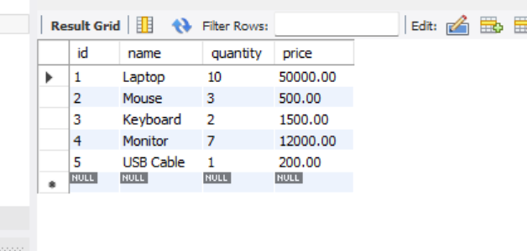
Tasks:
- Find low stock products (quantity < 5)
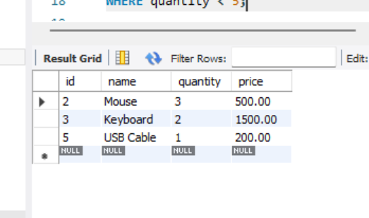

- Calculate total inventory value
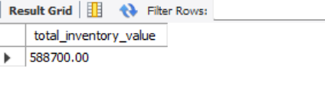

- Update stock after sale
